Example of Model Diagnostics

Calculator Maintenance Data Using EXCEL

First, we begin with the original data. I have sorted it with respect to the predictor variable (X = number of machines serviced). Note that in this case we wish to preserve the pairs (X_{i},Y_{i}). To do this:

- Move the cursor into the field of data
- Click on Data on the main toolbar, then Sort
- Select Column 2 (X) and Ascending. If you have already placed headers on the columns, make sure you click on the correct option regarding headers.

Y (minutes) | X (Machines)
10 | 1
17 | 1
33 | 2
25 | 2
39 | 3
62 | 4
53 | 4
49 | 4
78 | 5
75 | 5
65 | 5
71 | 5
68 | 5
86 | 6
97 | 7
101 | 7
105 | 7
118 | 8

Diagnostics for the Predictor Variable (Section 3.1)

X-values that are far away from the rest of the others can exert a lot of influence on the least squares regression line. A histogram or bar chart of the X-values can identify any potential extreme values. The following steps in EXCEL can be used to obtain a histogram of the X-values. A copy of the histogram is given below the instructions.

- Select Tools on the header bar, then Data Analysis (you may need to add it in from add-ins), then Histogram
- For the Input Range, highlight the column containing X (if you have included the header cell, click on Labels).
- Click Chart Output then OK.
- You may experiment and make the chart more visually appealing if preparing reports, but for investigating the model assumptions, this is fine.

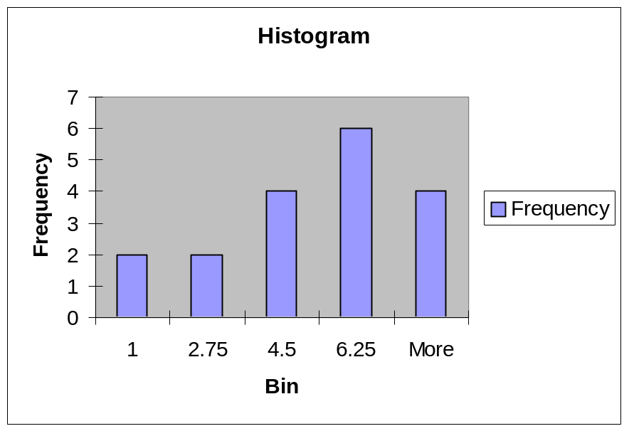

Residuals (Section 3.2)

The model assumptions are that the error terms are independent and normally distributed with mean 0 and constant (with respect to levels of X) variance σ². The errors are:

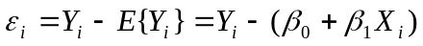

Since the model parameters are unknown, we cannot observe the actual errors. However, if we replace the unknown parameters, we have an “estimate” of each residual by taking the difference between the actual and fitted values. These are referred to as the residuals:

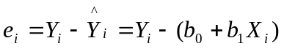

These residuals should approximately demonstrate the same behavior as the true error terms (the approximation will be better as the sample size increases). Some important properties concerning the residuals:

- Mean: 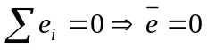 Shown in Chapter 1. Thus, the residuals have mean 0
- Variance: 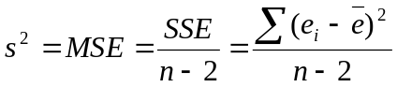
- Independence: Residuals are not independent due to: 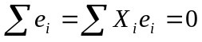

For large samples, relative to the number of model parameters, the dependency is unimportant.

Note that under the model assumptions, if we standardize the errors by subtraction off their mean (which is 0) and divide through by their standard deviation, then they have a standard normal (Z) distribution:

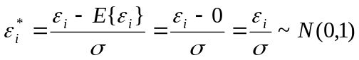

Semistudentized Residuals are quantities that approximate the standardized errors, based on the fitted equation. They are based on the estimates of the unknown errors (the residuals) and the estimate of the error standard deviation. These can be used to identify outlying observations since these are “like” Z-scores:

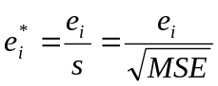

Note that the residuals have complicated standard deviations that are not constant (we will pursue this later in course), so this is an approximation. EXCEL produces Standardized Residuals, which appear to be computed as:

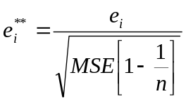

The denominator is the square root of the average variance of the residuals. Note as the sample size increases these are very similar quantities. For purposes of identifying outlying observations, either of these is useful.

Obtaining Residuals in EXCEL

- Choose Tools, Data Analysis, Regression
- Highlight the column containing Y, then the column containing X, then the appropriate Labels option
- Click on Residuals and Standardized Residuals
- Click OK
- The residuals will appear on a worksheet below the ANOVA table and parameter estimates. Also printed are observation number, predicted (fitted) values, and standardized residuals.

Regression Statistics
Multiple R | 0.990215218
R Square | 0.980526177
Adjusted R Square | 0.979309063
Standard Error | 4.481879999
Observations | 18

ANOVA
 | df | SS | MS | F | Significance F
Regression | 1 | 16182.6 | 16182.6 | 806 | 4.09733E-15
Residual | 16 | 321.4 | 20.1
Total | 17 | 16504

Observation | Predicted Y (minutes) | Residuals | Standard Residuals
1 | 12.41610738 | -2.416107383 | -0.555674513
2 | 12.41610738 | 4.583892617 | 1.054238034
3 | 27.15436242 | 5.845637584 | 1.344423613
4 | 27.15436242 | -2.154362416 | -0.495476441
5 | 41.89261745 | -2.89261745 | -0.665265875
6 | 56.63087248 | 5.369127517 | 1.234832251
7 | 56.63087248 | -3.630872483 | -0.83505531
8 | 56.63087248 | -7.630872483 | -1.755005337
9 | 71.36912752 | 6.630872483 | 1.52501783
10 | 71.36912752 | 3.630872483 | 0.83505531
11 | 71.36912752 | -6.369127517 | -1.464819758
12 | 71.36912752 | -0.369127517 | -0.084894717
13 | 71.36912752 | -3.369127517 | -0.774857237
14 | 86.10738255 | -0.10738255 | -0.024696645
15 | 100.8456376 | -3.845637584 | -0.8844486
16 | 100.8456376 | 0.154362416 | 0.035501427
17 | 100.8456376 | 4.154362416 | 0.955451454
18 | 115.5838926 | 2.416107383 | 0.555674513

Diagnostics for Residuals (3.3)

Obtaining a Plot of Residuals Against X (e_{i} vs X_{i})

- Copy and paste the column of Residuals to the original spreadsheet in Column C.
- Highlight Columns B and C and click on the Chart Wizard icon
- Click on XY (Scatter) then click through the dialog boxes
- Using all default options, your plot will appear as below.

Y (minutes) | X (Machines) | Residuals
10 | 1 | -2.41611
17 | 1 | 4.583893
33 | 2 | 5.845638
25 | 2 | -2.15436
39 | 3 | -2.89262
62 | 4 | 5.369128
53 | 4 | -3.63087
49 | 4 | -7.63087
78 | 5 | 6.630872
75 | 5 | 3.630872
65 | 5 | -6.36913
71 | 5 | -0.36913
68 | 5 | -3.36913
86 | 6 | -0.10738
97 | 7 | -3.84564
101 | 7 | 0.154362
105 | 7 | 4.154362
118 | 8 | 2.416107

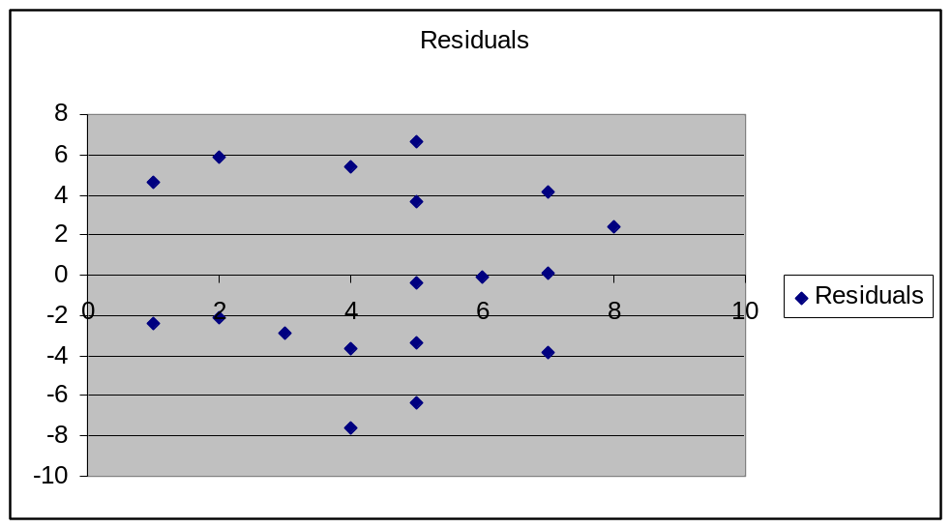

Plots of residuals versus predicted values and residuals versus time order (when data are collected over time) would be obtained in similar manners. Simply copy and paste columns of interest to new columns, placing the variable to go on the horizontal (X) axis to the left of the variable to go on the vertical (Y) axis.

Normality of Errors

The simplest way to check for normality of the error terms is to obtain a histogram of the residuals. There are several ways to do this, the simplest being as follows:

- Choose Tools, Data Analysis, Histogram
- Highlight the column containing the Residuals
- Choose appropriate Labels choice
- Click Chart Output then OK

A crude histogram will appear which is fine for our purposes. You may wish to experiment with EXCEL to obtain more elegant plots.

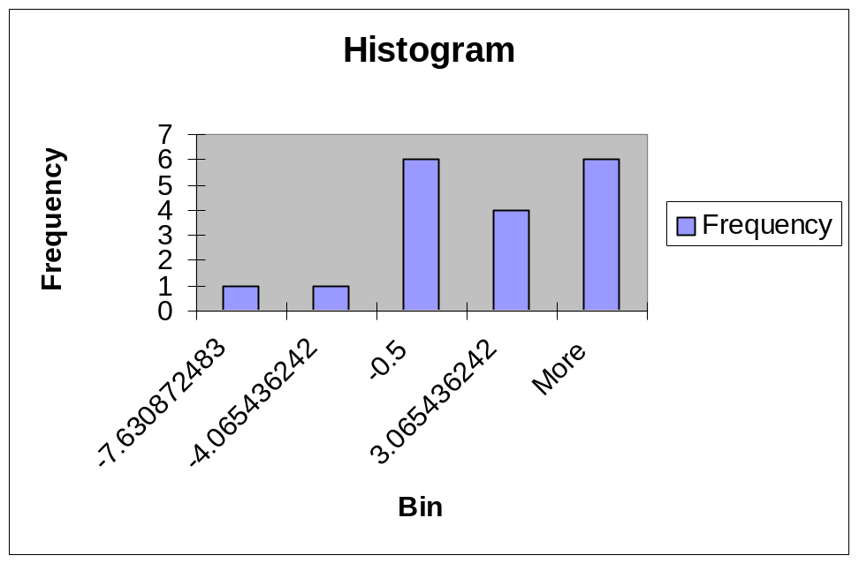

Note that you can choose bin upper values that are more satisfactory.

- Type in desired upper endpoints of bins in a new range of cells
- Choose Tools, Data Analysis, Histogram
- Highlight the column containing the Residuals
- For Bin Range highlight the range of values you’ve entered (include a label)
- Choose appropriate Labels choice
- Click on Chart Output then OK

residual
-7.5
-2.5
2.5
7.5

The ranges will be:
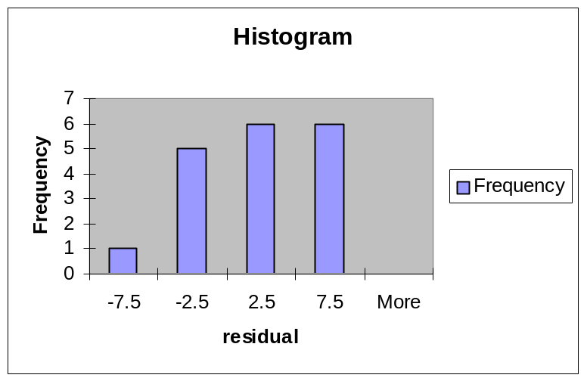

Computing Expected Residuals Under Normality

- Copy the cells containing Observation and Residuals to a new worksheet in Columns A and B, respectively.
- Highlight the column of Residuals then select Data and Sort then click on Continue with Current Selection then OK. Note that the residuals are in ascending order and the observation number represents the rank now, as opposed to i
- Compute the percentile representing each residual in their empirical distribution. Go to Cell C2 (assuming that you have a header row with labels). Then type:
=((A2-0.375)/(n+0.25)) where n is the sample size (type the number)
- Highlight Cell C2, then Copy it. Then highlight the next n-1 cells in column C, then Paste.
- Compute the Z values from the standard normal distribution corresponding to the percentiles in column C. Go to Cell D2 (assuming that you have a header row with labels). Then type: =NORMSINV(C2)
- Highlight Cell D2, then Copy it. Then highlight the next n-1 cells in column D, then Paste.
- Compute the Expected residuals under normality by multiplying the elements of Column D by 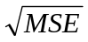 . This could be done in Column E.

The results of the steps are shown below:

First, put observation number and residuals in a new worksheet:

Observation | Residuals
1 | -2.41611
2 | 4.583893
3 | 5.845638
4 | -2.15436
5 | -2.89262
6 | 5.369128
7 | -3.63087
8 | -7.63087
9 | 6.630872
10 | 3.630872
11 | -6.36913
12 | -0.36913
13 | -3.36913
14 | -0.10738
15 | -3.84564
16 | 0.154362
17 | 4.154362
18 | 2.416107

Second, sort only the residuals:

Observation | Residuals
1 | -7.63087
2 | -6.36913
3 | -3.84564
4 | -3.63087
5 | -3.36913
6 | -2.89262
7 | -2.41611
8 | -2.15436
9 | -0.36913
10 | -0.10738
11 | 0.154362
12 | 2.416107
13 | 3.630872
14 | 4.154362
15 | 4.583893
16 | 5.369128
17 | 5.845638
18 | 6.630872

Third, compute the percentiles (notice that they are symmetric around 0.5). Here n=18

Observation | Residuals | percentile
1 | -7.63087 | 0.034247
2 | -6.36913 | 0.089041
3 | -3.84564 | 0.143836
4 | -3.63087 | 0.19863
5 | -3.36913 | 0.253425
6 | -2.89262 | 0.308219
7 | -2.41611 | 0.363014
8 | -2.15436 | 0.417808
9 | -0.36913 | 0.472603
10 | -0.10738 | 0.527397
11 | 0.154362 | 0.582192
12 | 2.416107 | 0.636986
13 | 3.630872 | 0.691781
14 | 4.154362 | 0.746575
15 | 4.583893 | 0.80137
16 | 5.369128 | 0.856164
17 | 5.845638 | 0.910959
18 | 6.630872 | 0.965753

Fourth, compute the Z-values from the standard normal distribution corresponding to the percentiles for the ordered residuals: 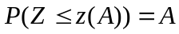

Observation | Residuals | percentile | z(pct)
1 | -7.63087 | 0.034247 | -1.82175
2 | -6.36913 | 0.089041 | -1.34668
3 | -3.84564 | 0.143836 | -1.06324
4 | -3.63087 | 0.19863 | -0.84652
5 | -3.36913 | 0.253425 | -0.66375
6 | -2.89262 | 0.308219 | -0.5009
7 | -2.41611 | 0.363014 | -0.35041
8 | -2.15436 | 0.417808 | -0.2075
9 | -0.36913 | 0.472603 | -0.06873
10 | -0.10738 | 0.527397 | 0.068728
11 | 0.154362 | 0.582192 | 0.207503
12 | 2.416107 | 0.636986 | 0.350415
13 | 3.630872 | 0.691781 | 0.500904
14 | 4.154362 | 0.746575 | 0.663752
15 | 4.583893 | 0.80137 | 0.846524
16 | 5.369128 | 0.856164 | 1.063245
17 | 5.845638 | 0.910959 | 1.346684
18 | 6.630872 | 0.965753 | 1.821745

Fifth, multiply the residual standard error () by the Z-values to obtain the expected residuals under normality.

Observation | Residuals | percentile | z(pct) | expected
1 | -7.63087 | 0.034247 | -1.82175 | -8.16142
2 | -6.36913 | 0.089041 | -1.34668 | -6.03315
3 | -3.84564 | 0.143836 | -1.06324 | -4.76334
4 | -3.63087 | 0.19863 | -0.84652 | -3.79243
5 | -3.36913 | 0.253425 | -0.66375 | -2.97361
6 | -2.89262 | 0.308219 | -0.5009 | -2.24405
7 | -2.41611 | 0.363014 | -0.35041 | -1.56986
8 | -2.15436 | 0.417808 | -0.2075 | -0.92962
9 | -0.36913 | 0.472603 | -0.06873 | -0.3079
10 | -0.10738 | 0.527397 | 0.068728 | 0.307903
11 | 0.154362 | 0.582192 | 0.207503 | 0.929616
12 | 2.416107 | 0.636986 | 0.350415 | 1.569858
13 | 3.630872 | 0.691781 | 0.500904 | 2.244051
14 | 4.154362 | 0.746575 | 0.663752 | 2.973607
15 | 4.583893 | 0.80137 | 0.846524 | 3.792426
16 | 5.369128 | 0.856164 | 1.063245 | 4.763337
17 | 5.845638 | 0.910959 | 1.346684 | 6.033145
18 | 6.630872 | 0.965753 | 1.821745 | 8.161418

Obtaining a Normal Probability Plot

- Copy the Residuals column to the right-hand side of the Expecteds column
- Highlight these 2 columns
- Click on Chart Wizard, then XY (Scatter), then click thru dialog boxes

Observation | Residuals | percentile | z(pct) | expected | Residuals
1 | -7.63087 | 0.034247 | -1.82175 | -8.16142 | -7.63087
2 | -6.36913 | 0.089041 | -1.34668 | -6.03315 | -6.36913
3 | -3.84564 | 0.143836 | -1.06324 | -4.76334 | -3.84564
4 | -3.63087 | 0.19863 | -0.84652 | -3.79243 | -3.63087
5 | -3.36913 | 0.253425 | -0.66375 | -2.97361 | -3.36913
6 | -2.89262 | 0.308219 | -0.5009 | -2.24405 | -2.89262
7 | -2.41611 | 0.363014 | -0.35041 | -1.56986 | -2.41611
8 | -2.15436 | 0.417808 | -0.2075 | -0.92962 | -2.15436
9 | -0.36913 | 0.472603 | -0.06873 | -0.3079 | -0.36913
10 | -0.10738 | 0.527397 | 0.068728 | 0.307903 | -0.10738
11 | 0.154362 | 0.582192 | 0.207503 | 0.929616 | 0.154362
12 | 2.416107 | 0.636986 | 0.350415 | 1.569858 | 2.416107
13 | 3.630872 | 0.691781 | 0.500904 | 2.244051 | 3.630872
14 | 4.154362 | 0.746575 | 0.663752 | 2.973607 | 4.154362
15 | 4.583893 | 0.80137 | 0.846524 | 3.792426 | 4.583893
16 | 5.369128 | 0.856164 | 1.063245 | 4.763337 | 5.369128
17 | 5.845638 | 0.910959 | 1.346684 | 6.033145 | 5.845638
18 | 6.630872 | 0.965753 | 1.821745 | 8.161418 | 6.630872

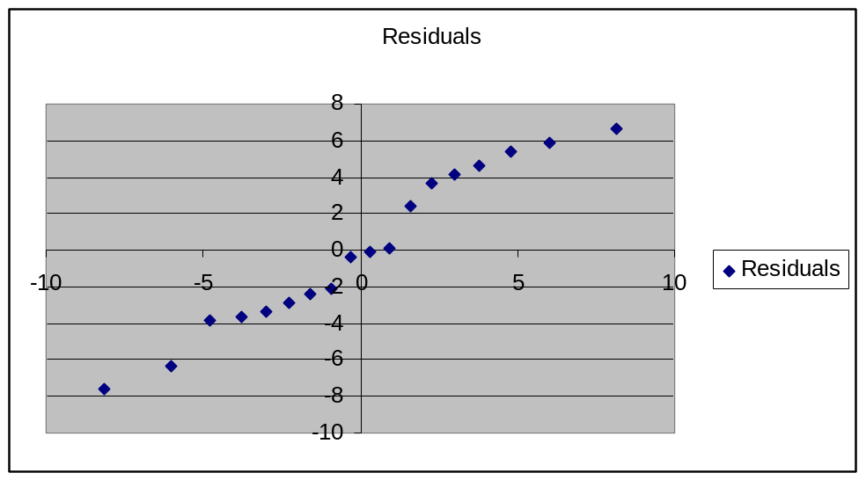
As always, you can make the plot more attractive with plot options, but it is unnecessary for our purposes of assessing normality. For this example, the residuals appear to fall on a reasonably straight line, as would be expected under the normality of errors assumption.

Correlation Test for Normality (3.5)

- 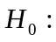Error terms are normally distributed
- 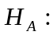Error terms are not normally distributed
- TS: Correlation coefficient between observed and expected residuals (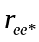)
- RR: 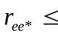 Tabled values in Table B.6, Page 1348 (indexed by α and n)

We can obtain the correlation coefficient between the observed and expected residuals as follows.

- Select Tools, Data Analysis, Correlation
- Highlight the columns for Residuals and Expected
- Click on Labels if they are included
- Click OK

 | expected | Residuals
expected | 1
Residuals | 0.980816 | 1

For this example, n=15 and with , we obtain a critical value of 0.946.
Since the correlation coefficient (0.981) is larger than the critical value, we conclude in favor of the null hypothesis. We conclude that the errors are normally distributed.

Modified Levene Test for Constant Variance (3.6)

To conduct this test in EXCEL, do the following steps:

- Split the data into two groups with respect to levels of X. Use best judgment in terms of balance and “closeness” of X levels. For our example a natural split is group 1: X = 1-4 and group 2: X = 5-8
- Obtain the Residuals from the regression. In a new worksheet put the residuals from group 1 in one column (say Column A), the residuals from group 2 in another column (say Column B). For this example, the group sizes are 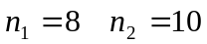
- Obtain the Median residual for each group. In Cell A15, type:
=median( A2:A9) (since we have n₁=8 and a header row).
In Cell B15, type: =median( B2:B11) (since we have n₂=10 and a header row).
- Obtain the absolute values of the differences between the residuals and their group medians in the next two columns. In Cell C2 type:
=abs(A2-$A$15) (the dollar signs make cut and paste work correctly)
Then Copy Cell C2 and Paste it to Cells C3-C9
In Cell D2 type: =abs(B2-$B$15)
Then Copy Cell D2 and Paste it to Cells D3-D11
- Obtain the mean and sum of squared deviations of the absolute difference from the median in the previous step.
In Cell F2 type: =average(C2:C9) (this computes 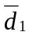)
In Cell F3 type: =devsq(C2:C9) (this computes 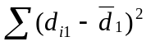)
In Cell G2 type: =average(D2:D11) (this computes 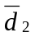)
In Cell G3 type: =devsq(D2:D11) (this computes 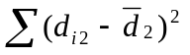)
- Compute s² . In Cell H2 type: =(F3+G3)/(18-2) (18=n)
- Compute 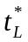. In Cell I2 type:
=(F2-G2)/sqrt(H2*((1/8)+(1/10))) (since n₁=8 and n₂=10)

The result of the steps on the calculator maintenance are shown below.

First, separate the residuals into Columns A and B:

Group 1 | Group 2
-2.41611 | 6.630872
4.583893 | 3.630872
5.845638 | -6.36913
-2.15436 | -0.36913
-2.89262 | -3.36913
5.369128 | -0.10738
-3.63087 | -3.84564
-7.63087 | 0.154362
 | 4.154362
 | 2.416107

Second, obtain the median residuals for each group:

Group 1 | Group 2
-2.41611 | 6.630872
4.583893 | 3.630872
5.845638 | -6.36913
-2.15436 | -0.36913
-2.89262 | -3.36913
5.369128 | -0.10738
-3.63087 | -3.84564
-7.63087 | 0.154362
 | 4.154362
 | 2.416107
-2.28523 | 0.02349

Third, obtain the absolute difference between the actual residuals and the group medians:

Group 1 | Group 2 | d1 | d2
-2.41611 | 6.630872 | 0.130872 | 6.607383
4.583893 | 3.630872 | 6.869128 | 3.607383
5.845638 | -6.36913 | 8.130872 | 6.392617
-2.15436 | -0.36913 | 0.130872 | 0.392617
-2.89262 | -3.36913 | 0.607383 | 3.392617
5.369128 | -0.10738 | 7.654362 | 0.130872
-3.63087 | -3.84564 | 1.345638 | 3.869128
-7.63087 | 0.154362 | 5.345638 | 0.130872
 | 4.154362 |  | 4.130872
 | 2.416107 |  | 2.392617
-2.28523 | 0.02349

Fourth, compute the statistics: mean and sum of squared deviations for the d values for groups 1 and 2:

Group 1 | Group 2 | d1 | d2 |  | stats 1 | stats 2
-2.41611 | 6.630872 | 0.130872 | 6.607383 |  | 3.776846 | 3.104698
4.583893 | 3.630872 | 6.869128 | 3.607383 |  | 88.55851 | 50.60191
5.845638 | -6.36913 | 8.130872 | 6.392617
-2.15436 | -0.36913 | 0.130872 | 0.392617
-2.89262 | -3.36913 | 0.607383 | 3.392617
5.369128 | -0.10738 | 7.654362 | 0.130872
-3.63087 | -3.84564 | 1.345638 | 3.869128
-7.63087 | 0.154362 | 5.345638 | 0.130872
 | 4.154362 |  | 4.130872
 | 2.416107 |  | 2.392617
-2.28523 | 0.02349

Fifth, Compute the pooled variance s²:

Group 1 | Group 2 | d1 | d2 |  | stats 1 | stats 2 | pooled s^2
-2.41611 | 6.630872 | 0.130872 | 6.607383 |  | 3.776846 | 3.104698 | 8.697526
4.583893 | 3.630872 | 6.869128 | 3.607383 |  | 88.55851 | 50.60191
5.845638 | -6.36913 | 8.130872 | 6.392617
-2.15436 | -0.36913 | 0.130872 | 0.392617
-2.89262 | -3.36913 | 0.607383 | 3.392617
5.369128 | -0.10738 | 7.654362 | 0.130872
-3.63087 | -3.84564 | 1.345638 | 3.869128
-7.63087 | 0.154362 | 5.345638 | 0.130872
 | 4.154362 |  | 4.130872
 | 2.416107 |  | 2.392617
-2.28523 | 0.02349

Sixth, compute the test statistic

Group 1 | Group 2 | d1 | d2 |  | stats 1 | stats 2 | pooled s^2 | t-stat
-2.41611 | 6.630872 | 0.130872 | 6.607383 |  | 3.776846 | 3.104698 | 8.697526 | 0.48048
4.583893 | 3.630872 | 6.869128 | 3.607383 |  | 88.55851 | 50.60191
5.845638 | -6.36913 | 8.130872 | 6.392617
-2.15436 | -0.36913 | 0.130872 | 0.392617
-2.89262 | -3.36913 | 0.607383 | 3.392617
5.369128 | -0.10738 | 7.654362 | 0.130872
-3.63087 | -3.84564 | 1.345638 | 3.869128
-7.63087 | 0.154362 | 5.345638 | 0.130872
 | 4.154362 |  | 4.130872
 | 2.416107 |  | 2.392617
-2.28523 | 0.02349

Finally, we can conduct the test:

For α = 0.05, we obtain: . Since our test statistic (0.48) does not exceed 2.120, we fail to reject the hypothesis of equal variances. We have no reason to believe that the error variance is not constant.

